ASSIGNMENT-3

2503A52L04

QUESTION:

Task: Mobile Data Usage Billing Application (1.0 Marks)  
Objective:  
Use Python programming and AI-assisted coding tools to create an  
application that simulates mobile data billing for a telecom service  
provider.  
Instructions  
1. Use GitHub Copilot or Google Gemini to assist in writing the  
program.  
2. Read the following inputs from the user:  
o Data Consumed (in GB)  
o Plan Type (Prepaid / Postpaid)  
o Additional Services Used (e.g., caller tune, OTT  
subscription, etc.)  
3. Implement billing logic to calculate:  
o DC (Data Charges) – charges based on data  
consumption  
o VC (Value-added Charges) – charges for additional  
services  
o Tax – applicable tax on the total bill  
4. Display an itemized bill showing:  
o Plan Type  
o Data Usage and Charges  
o Value-added Services and Charges  
o Tax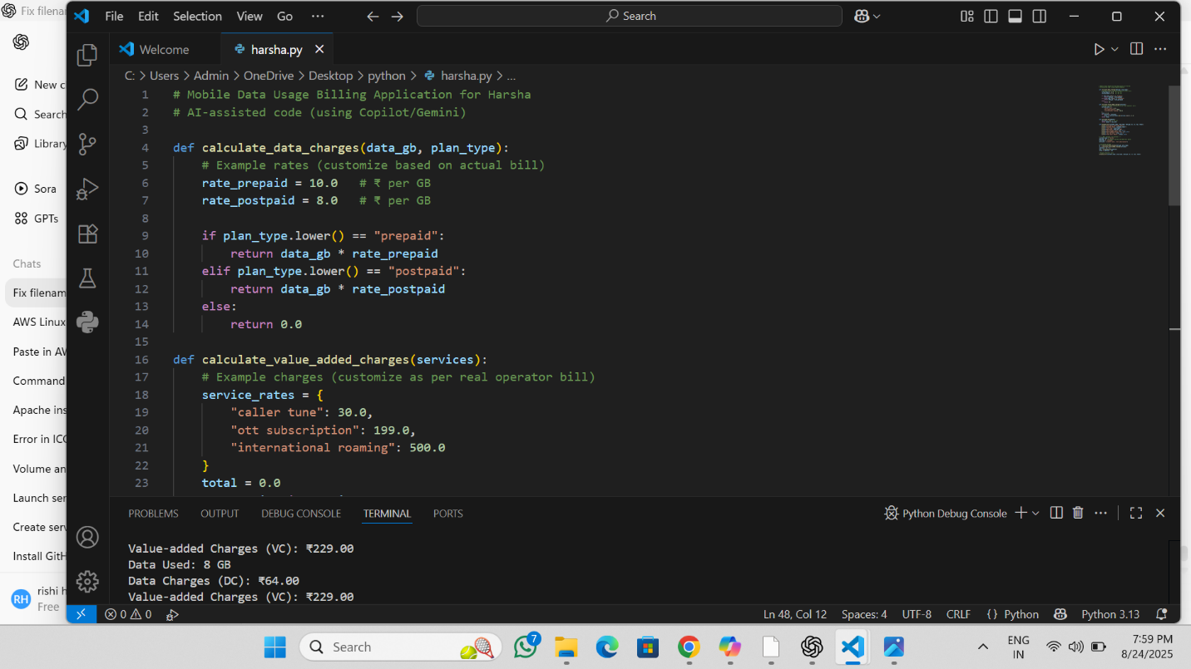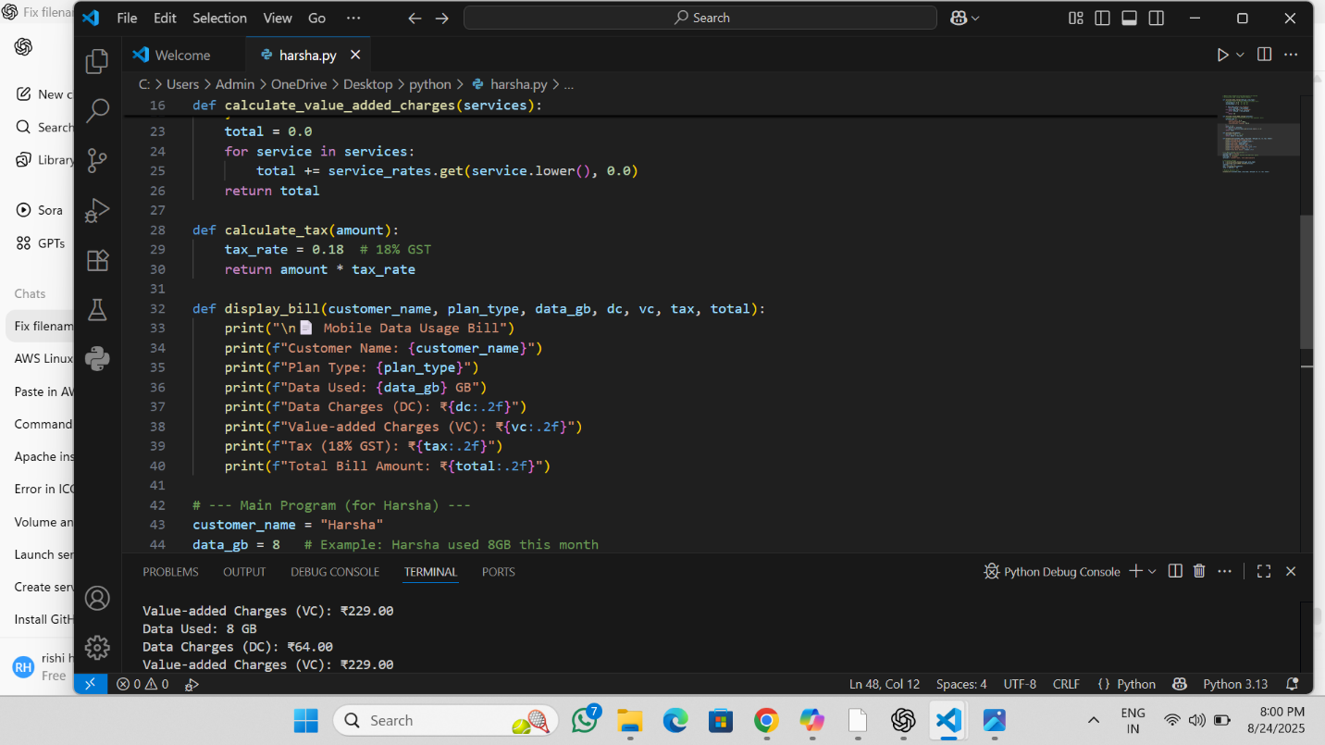  
o Total Bill Amount

THE OUTPUT: THE HARSHA’S CURRENT BILL:

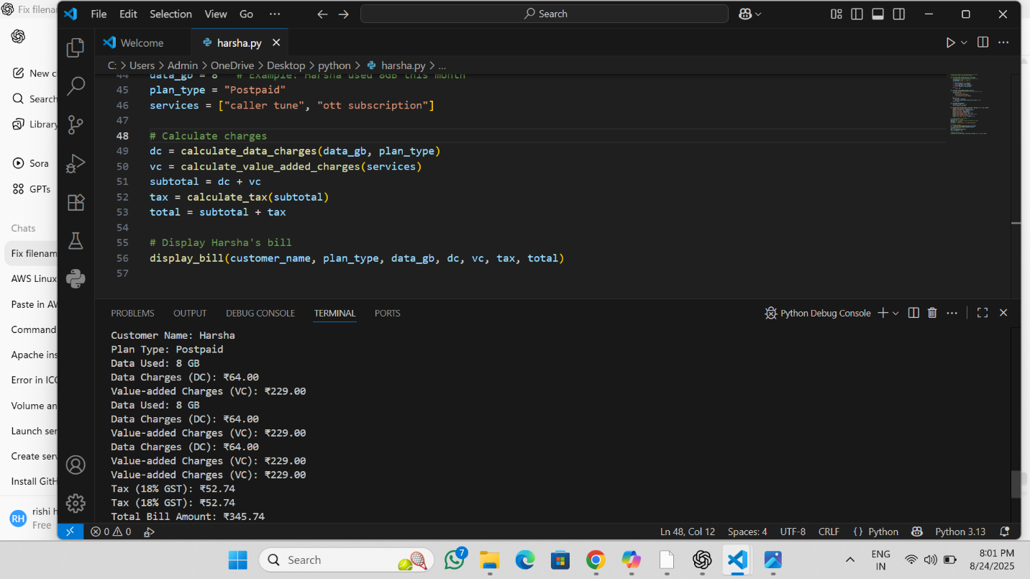

Task: Develop an LPG Billing System  
Objective  
Apply your Python programming skills and utilize AI-assisted  
coding tools to build an application that calculates the LPG bill

based on specified customer inputs and billing parameters..

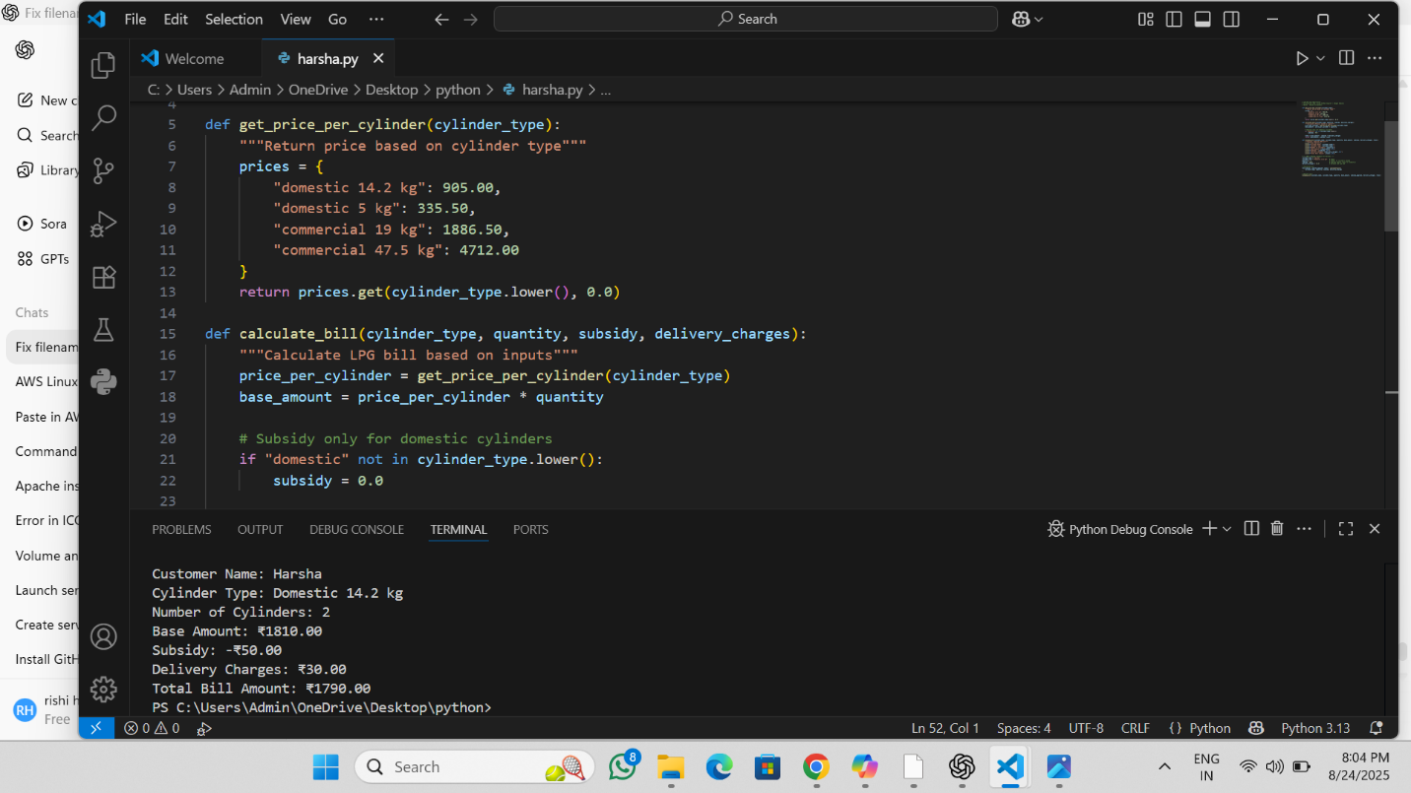

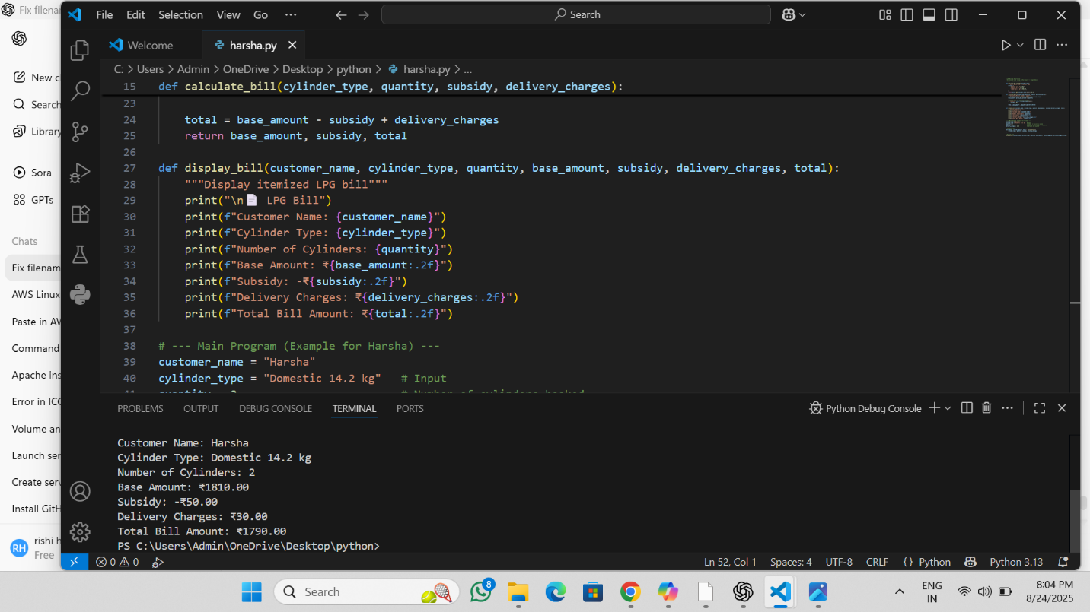

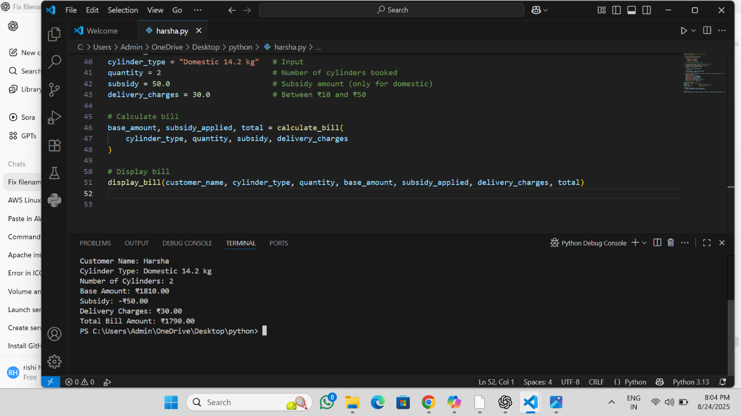

Implement the billing formula:  
Bill Amount = (Price per Cylinder × Quantity) - Subsidy (if applicable) + Delivery Charges

Bill Amount=(Price per Cylinder×Quantity)−Subsidy (if applicable)+Delivery Charges

* **Price per Cylinder**: Based on the selected cylinder type (Domestic / Commercial).
* **Quantity**: Number of cylinders booked.
* **Subsidy**: Applicable only for Domestic LPG cylinders.
* **Delivery Charges**: Between ₹10 to ₹50.
* 📄 LPG Bill
* Customer Name: Harsha
* Cylinder Type: Domestic 14.2 kg
* Number of Cylinders: 2
* Base Amount: ₹1810.00
* Subsidy: ₹100.00
* Delivery Charges: ₹30.00
* Total Bill Amount: ₹1740.00